You are receiving this email as a member of the media.
If you wish to unsubscribe from future messages, please reply with UNSUBSCRIBE in the subject line.

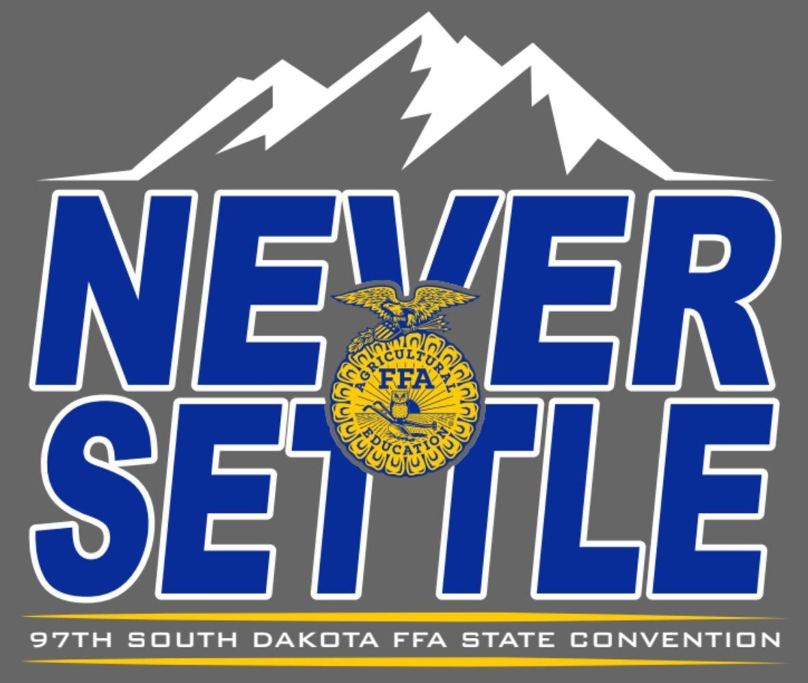
NEWS RELEASE

Website: www.sdaged.org
Facebook: www.facebook.com/South.Dakota.FFA
Instagram: @sdffaassociation
For more information, contact:
Caroline Hansen
South Dakota Leadership and Program Manager
Caroline.hansen@sdaged.org
South Dakota FFA Association

FOR IMMEDIATE RELEASE
March 26, 2025

FFA Members Receive State FFA Degree
BROOKINGS, South Dakota – 324 South Dakota FFA members will be recognized for receiving their State FFA Degree at the 97th South Dakota State FFA Convention, Friday April 4th, 2024, at 4:00 pm. Join us in helping them celebrate! You can also watch the convention live at www.sdaged.org, Newscenter1.tv, and ConnectCenter1.tv and KAUN TV stations.

The State Degree is the highest honor the South Dakota FFA Association can bestow upon its members. In order to achieve the award, members must meet the following requirements; have received their Chapter FFA Degree, been an FFA member and agricultural education student for at least two years, earned at least $2,000, or worked 600 hours in their Supervised Agricultural Experience program, given a six-minute speech about agriculture or FFA, participated in eight different leadership activities, received a “C” average or better in high school and shown a record of outstanding leadership and community involvement.

As a special project of the SD FFA Foundation, South Dakota FFA members will receive the golden charm of the State Degree, a symbol of the member’s growth and development, and a framed certificate, thanks to the following sponsors: Todd & Barbara Powell; Barry & Jenny Jacobson; The Jacobson Group LLC; West Central FFA Alumni; Rechelle & Eric Dissing; Dan Streff Family; Sandy Osterday; CharLee Bachman; Kent Buchholz; Noelle & Andrew Swanson; Kevin & Amber Blagg; Steven Zemlicka; Myles & Mercedes Snedeker; Red River Farm Network; Dacotah Diamond Auctions and Equipment; Jeff & Beth Vanderwal; Peterson Livestock; First PREMIER Bank; Lance Howe; Kyle & Jordanne Arbach, Wyatt & Zana DeJong; Dani Herring; Stella Nagel; Olson Family; Dawnwind Dairy Goats; and Wendy Mortenson Agency.
The 324 FFA members who received their State FFA Degree are:

Alcester-Hudson
Ethan Bovill
Devin Hongslo

Arlington
Caden Phelps
Preston Singrey

Belle Fourche
Alexis Hogen
Taya Kirstine
Wyatt Lesmeister
Lydia Main
Bailey Moke

Beresford
Elana Andrews
Isaac Boden
Ethan Hauck
Talen Hazel
Kayla Jensen
Cole Johnson
Kylie Mockler
Capri Mullinix
Grace Norling
Andrew VanKekerix
Allie Westra
Bon Homme
Gram Gause
Addison Hovorka
Kolbe Jelsma
Jackson Kaul
Kenadee Kozak
Adley Scheuerman
Landon Schmidt
Anahwyn Soukup
Hunter Stark

Bridgewater-Emery
Braxton Burnham
Hayden Hofer
Austin Kjetland
Dawson Plagmann
Grace Stacken
Katrina Thon
Dylan Wollman
Jason Zeeb

Brookings
Ella Feucht
Mikalyn Kelly
Connor May
Kennedy Nemitz
Josie Nold
Riley Rasmussen
Mackenzie Steinhauer
Gabriel Stern
Jordyn Tibbs
Landin Tucker

Buffalo Christian
Josie Johnson

Canton
Cordelia Adams
Chance Riley
Jenna Vande Weerd
Corbin Winquist

Centerville
Isaac Marohl

Chester
Lexi Bauman
Madlyn Borecky
Karmen Bonnie Iverson
Isabella Ann Schmidt

Clark
Avery Lee
Lauren Luvaas
DeSmet
Gannon Michael Gilligan
Tanner J Tolzin
Dell Rapids
Megan Geraets
Saywer Geraets

Doland
Reganne Miles
Emma Schneider
Edmunds Central
Theodore Haerter
Kelsey Lehr

Elkton
Rylen Coe
Brooklyn Grooters
Ashton Neill
Caleb Seiler
Jack Skordahl
Jackson Smallfield

Ethan
Ashley Clauson
Hunter Dean
Cole Hinckley
William Kreth
Madisyn Raymond

Faulkton
Cord Brand
Charlie Deiter
Lincoln Dikoff
Reese Hadrick
Trey Machtemes

Freeman
Elizabeth Anderson
Claire Hofer
Justice Mehlhaf
Olivia Smith
Erica Swensen

Garretson
Lane Ellefson
Tyler Erickson
Jakob Gnadt
Colin Shellum
Martin Welch

Gregory County
Nick Kenzy
Avery Zeisler

Groton
Kellen Antonsen
Ashley Johnson
Payton Mitchell

Harrisburg
Isabelle Madelynn Carlson
Khloe Johnsen
Andrew Johnson
Mason Kieffer
Elizabeth Kockelman
Briley Rilling
Cooper Rilling
Leia Rombough
Isabella Smithback
Conner Weber

Hitchcock-Tulare
Blaze Binger
Cooper Cole
Lainee Humphrey
Mikael Nielson
Katelyn Schroeder
Nick Tollefson

Hot Springs
Alexandra Burgess
Jayla Evans
Lyzzie Rapp

Hoven
Ethan Johnson
Abilene McGuire
Taylyn Rausch
Erica Sautner
Lane Stuwe

Howard
Ellie Becker
Melanie Marie Calmus
Lucas Feldhaus
Trent Gunnar Feldhaus
Calvin Halverson
Carson Hinker
Mason Daniel Jacobson
Tate Miller
Austin Mark Severson
Harris Terwilliger

Huron
Erianna DeVries
Hannah Schoenfelder
Kenna Dickson

Kimball
Graden Holan
Shayda Ness
Madilynn Von Eye

Lemmon
Gage Anderson
Blake Drayton
Blair Ham
Sidney Maher
Emma O’Donnell
Nathan Penfield
Cash Schiley
Samuel Weishaar
Arlus Yalowizer

Lennox Sundstrom
Megan Luvaas
Skyler Plucker
Faith Poppens
Tyler Strasser
Madison Central
James M Bame
Ava Caroline Brandenburger
Carter Downs
Cole Downs
Brayden Gust
Trevor Harms
Cambree Hunsley
Kade Klein
Lyndsey Litz
Ryan Morse

McCook Central
Preston Bradley
Abbie Chase
Lane Deutsch
Landon Flogstad
Joseph Grady
Blake Klitzke
Madison Lauck
Dylan McGregor
Lauren Roling
Ava Sieverding
Colton Stiefvater
Karlie Stiefvater

Milbank
Veronica Fonder

Miller
Eli Batin
Marshall Conkey
Emma Fritzsche
James Fritzsche
Kellan Hurd
James Lammers

Mitchell
Lainee Forst
Cailee Kirkpatrick
Ashlyn Roudabush
Delaney Zoss

Montrose
Cloey Deters
Makarie Wiebersick

Northwestern
Patrick Olson
Adiana Ratigan
Jessica Spurr
Dallas Stoltenberg

Oldham-Ramona-
Rutland
Garet Wicks

Parker
Halle Berens
Michael Even
Jerry Friman
Nevaeh Podhradsky
Allison Skinner

Parkston
Drew Braley
Breckin Culbert
Taylor Fink
Elliott Leischner
Emily Walz

Philip
Alex Baker
Jensen Fitch
Fayth Martin
Race O’Connor
Wade Piroutek
Mattisen Reckling
Morgan Sammons
Ashley Schriever
Lukas VanderMay

Platte Geddes
Coy Bultsma
Rehme Dibbet
Justin Groon
Emily Hickey
Emmit Holzbauer
Josie Muilenburg
Sydney Neuman
Kalli Summerville
Riley Timmerman

Rapid City Stevens
Jadyn Bennett
Henry Hovde
Alexa Roland
Patty Timmons
Daphne White
Tucker Wuertzer

Redfield
Creighton Bowar
Collin Dean
Brooklyn Rische
Logan Siebrecth

Sanborn Central/ Woonsocket
Emilie Lindgren

Scotland
Trinity Bietz
Emily Dvorak

Sioux Falls CTE
Brody Stenger
Amanda Wolf

Sioux Valley
Kylie Christensen
Matthew Field
Cayce Hoeke
Luke Lembcke
Mathew Olson
Elise Owen
Trevor Shultz
Seth VanderWal

Sisseton
Hannah Hannasch
Bradley Hansen
Sidney Johnson
Kate Meyer
Mason Shultz
Taylor Snaza

Sturgis
Bennett Gordon

Sully Buttes
Evia Buhler
Ely Heuertz
Taydon LaRosh
Teghan Westphal

Sunshine Bible Academy
Jimmy Burma
Savannah Hall
Kennedy Keck

Tea Area
Colton Duffy
Remington Jacobson
Megan Ritnour
Parker Wilson

Tri-Valley
Espn Althoff
Corral Benson
Zoe Dissing
McKenzie Dow
Brea Janes
McKenzie Mack
Ireland McAreavey
Emery Pearson
Reagan Pearson
Carson Sanders
Bracken Sharpe
Kylie Slining
Corie Wicks

Viborg-Hurley
LaMiya Baker
Parker Christensen
Rachael Feiock
Justin VanHull

Wall
Lonnie Elshere
Faith Frink
Natalie Mickelson
Lucy Moon
Laramie Nutter
Webster
Dylan Carlson
Blaise McGregor
Jaidryn Rice
Norah Zubke

Wessington Springs
Landen Christensen
Lucas Christensen
Ranick Fjerstad
Braden Flowers
Karter Mebius
Sam Poncelow
Ridge Roduner
Bailey Yost

West Central
Allison Brost
Mya Joan Marie Davidson
Reece Gerlach
Cain Grocott
Hannah Haase
Samuel Handberg
Aiden Healy
Kasey Kalb
Seth Lind
Natalie Morgan
Cooper Mulder
Cody Opitz

Willow Lake
Cayson Trav Bratland
Elliot Hayden Bratland
Samantha Jo Brenden
Kaylyn Marie Hofer
Josh Mark Kannegieter
Shay Marie Michalski
Nora Jean Terhark
Tehya Catherine Vig
Ginny Warkenthien

Wilmot
Mya Heinje
Rhyanna Rudebusch

Winner
Austin Blare
Andrew Henderson
Kyla Mammen
Hunter Shippy

Wolsey-Wessington
Rachel Boomsma
Brylee Furhman
Modesty Heath

-###-

